The Cosmic Power of Sin in Paul's Letter to the Romans:
Toward a Widescreen Edition
BEVERLY ROBERTS GAVENTA
Professor of New Testament Princeton Theological Seminary
Paul's letter to the Romans depicts Sin as one of the anti-God powers whose final defeat the death and resurrection of Jesus Christ guarantees. The framework of cosmic battle is essential for reading and interpreting this letter in the life of the church.
No form of Christian teaching has any future before it except such as can keep steadily in view the reality of the evil in the world, and go to meet the evil with a battle-song of triumph.
1 Gustav Aulén
Here at Christ Church, we don't have sin." Stunning as it may be, this state- ment was made to a pastor of my acquaintance early in his current pas- torate. What precisely the statement was intended to convey remains obscure, but it conjures up the range of ways in which contemporary Christians convey
their discomfort with talk about sin (at least as sin pertains to themselves). A friend told me that she could not sing "Amazing Grace," as she had never been a "wretch" who required saving. Congregations seeking a more "positive" worship experience relegate prayers of confession to the dustbin with the explanation that people prefer not to think about sin.
The people who inhabit these anecdotes would surely find themselves ill at ease with Paul's letter to Christians at Rome. More than anywhere else in the New Testament, the
2
language of sin flourishes here.
to sin, sinful) appear 81 times in the undisputed letters of Paul, and 60 of those instances
^ h e statement appears in the closing paragraph in Gustaf Aulén's Christus Victor, trans. A. G. Herbert
(London: SPCK, 1931) 176. The context makes clear that Aulén understands the triumph to be accomplished by
God.
2
the word hamartia and its cognates a combination of 27 times.
The noun hamartia (sin) and words related to it (sinner,
Note, however, that the word group is proportionately more pervasive in the far briefer 1 John, which employs
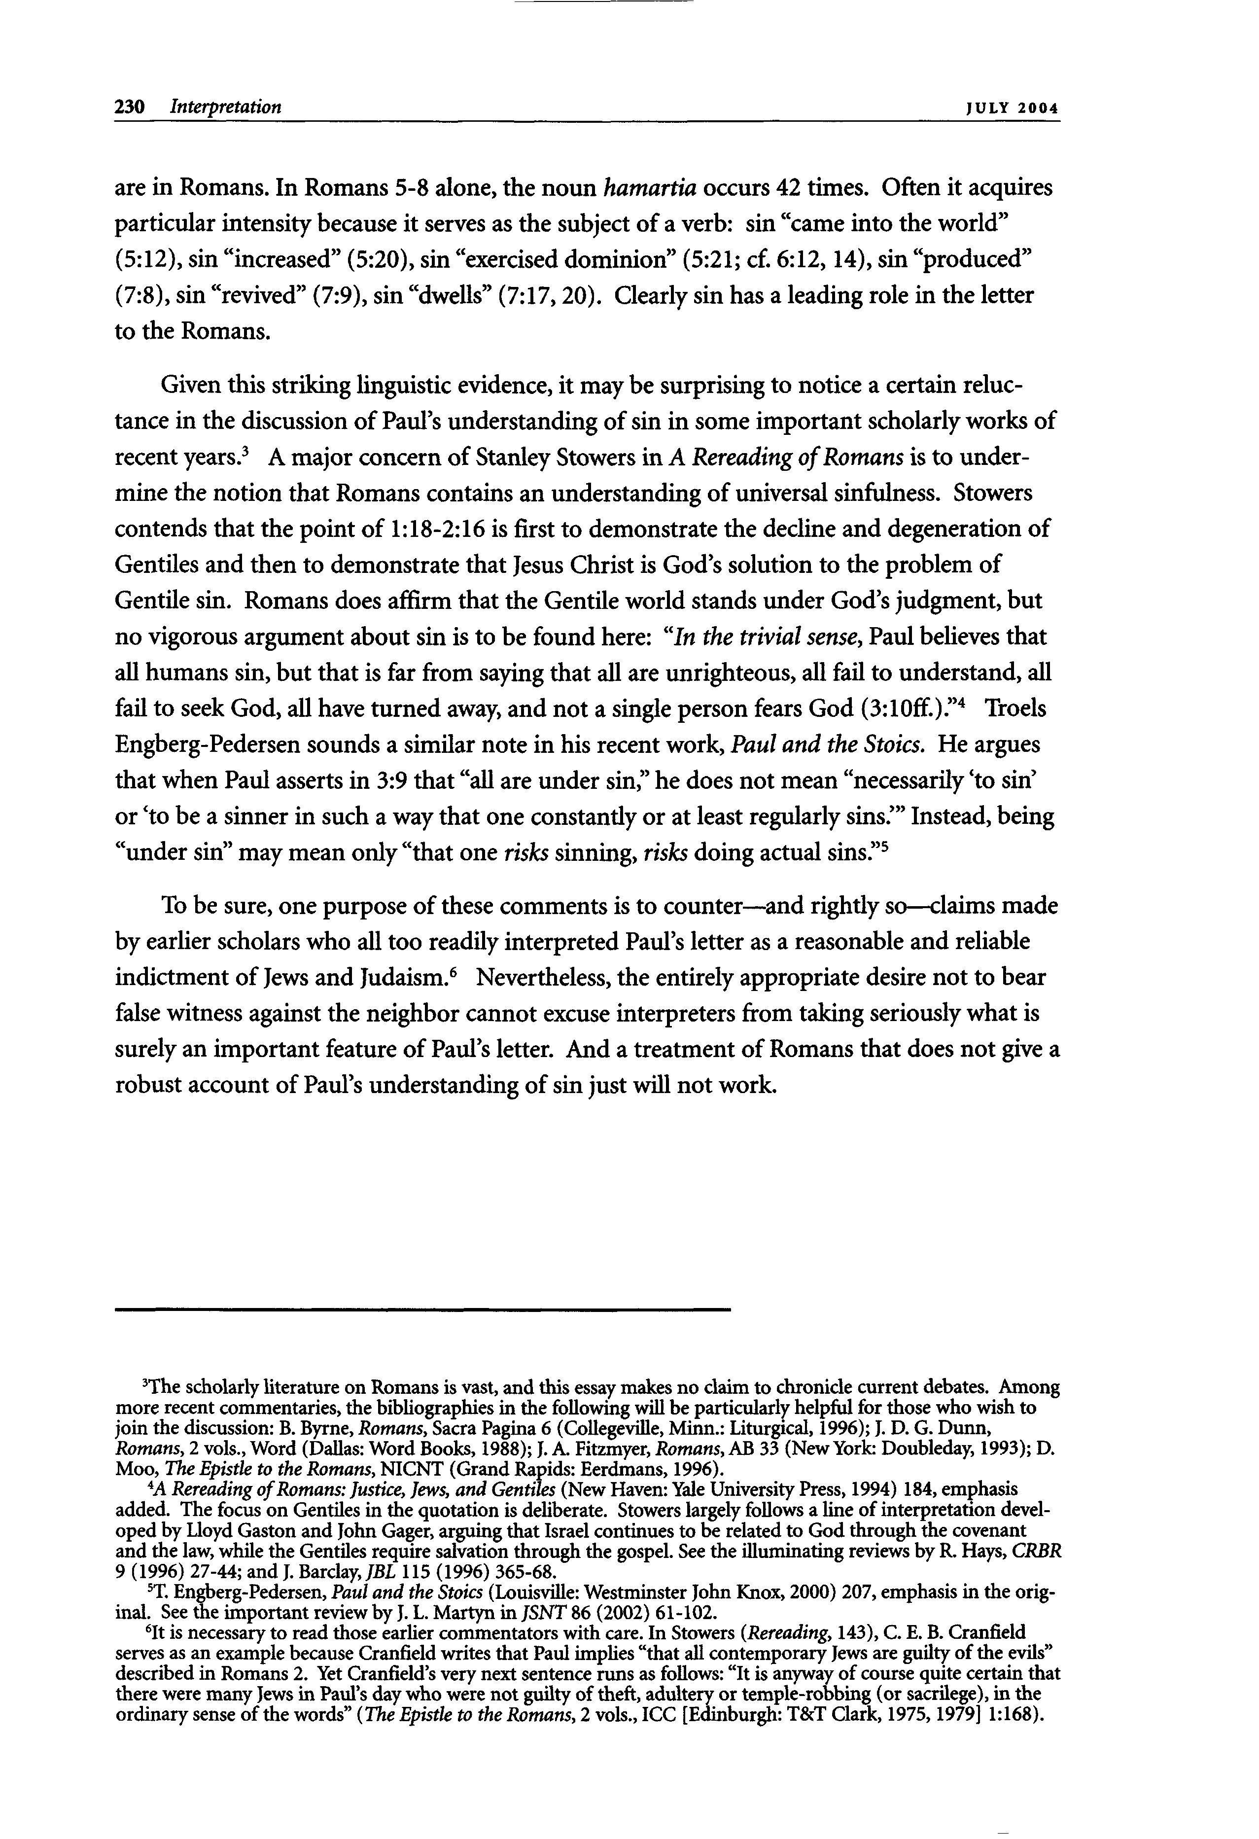
230 Interpretation JUL Y 2 0 0 4
are in Romans. In Romans 5-8 alone, the noun hamartia occurs 42 times. Often it acquires particular intensity because it serves as the subject of a verb: sin "came into the world" (5:12), sin "increased" (5:20), sin "exercised dominion" (5:21; cf. 6:12,14), sin "produced" (7:8), sin "revived" (7:9), sin "dwells" (7:17,20). Clearly sin has a leading role in the letter to the Romans.
Given this striking linguistic evidence, it may be surprising to notice a certain reluc- tance in the discussion of Paul's understanding of sin in some important scholarly works of
3
recent years.
mine the notion that Romans contains an understanding of universal sinfulness. Stowers contends that the point of 1:18-2:16 is first to demonstrate the decline and degeneration of Gentiles and then to demonstrate that Jesus Christ is God's solution to the problem of Gentile sin. Romans does affirm that the Gentile world stands under God's judgment, but no vigorous argument about sin is to be found here: "In the trivial sense, Paul believes that all humans sin, but that is far from saying that all are unrighteous, all fail to understand, all
4
fail to seek God, all have turned away, and not a single person fears God (3:10ff.)." Troels
Engberg-Pedersen sounds a similar note in his recent work, Paul and the Stoics. He argues that when Paul asserts in 3:9 that "all are under sin," he does not mean "necessarily 'to sin' or 'to be a sinner in such a way that one constantly or at least regularly sins.'" Instead, being
5 "under sin" may mean only "that one risks sinning, rish doing actual sins."
To be sure, one purpose of these comments is to counter—and rightly so—claims made by earlier scholars who all too readily interpreted Paul's letter as a reasonable and reliable
6
indictment of Jews and Judaism.
false witness against the neighbor cannot excuse interpreters from taking seriously what is surely an important feature of Paul's letter. And a treatment of Romans that does not give a robust account of Paul's understanding of sin just will not work.
A major concern of Stanley Stowers in A Rereading of Romans is to under-
Nevertheless, the entirely appropriate desire not to bear
3
The scholarly literature on Romans is vast, and this essay makes no claim to chronicle current debates. Among
more recent commentaries, the bibliographies in the following will be particularly helpful for those who wish to join the discussion: B. Byrne, Romans, Sacra Pagina 6 (Collegeville, Minn.: Liturgical, 1996); J. D. G. Dunn, Romans, 2 vols., Word (Dallas: Word Books, 1988); J. A. Fitzmyer, Romans, AB 33 (New York: Doubleday, 1993); D.
A Rereading of Romans: Justice, Jews, and Gentiles (New Haven: Yale University Press, 1994) 184, emphasis added. The focus on Gentiles in the quotation is deliberate. Stowers largely follows a Une of interpretation devel- oped by Lloyd Gaston and John Gager, arguing that Israel continues to be related to God through the covenant
and the law, while the Gentiles require salvation through the gospel. See the illuminating reviews by R. Hays, CRBR
Moo, The Epistle to the Romans, NICNT (Grand Rapids: Eerdmans, 1996). 4
9 (1996) 27-44; and J. Barclay, JBL 115 (1996) 365-68. 5
T. Éngberg-Pedersen, Paul and the Stoics (Louisville: Westminster John Knox, 2000) 207, emphasis in the orig- inal. See the important review by J. L. Martyn in JSNT 86 (2002) 61-102.
6
It is necessary to read those earlier commentators with care. In Stowers (Rereading, 143), C. E. B. Cranfield serves as an example because Cranfield writes that Paul implies "that all contemporary Jews are guilty of the evils" described in Romans 2. Yet Cranfield's very next sentence runs as follows: "It is anyway of course quite certain that there were many Jews in Paul's day who were not guilty of theft, adultery or temple-robbing (or sacrilege), in the ordinary sense of the words'' (The Epistle to the Romans, 2 vols., ICC [Edinburgh: Τ&Ύ Clark, 1975,1979] 1:168).
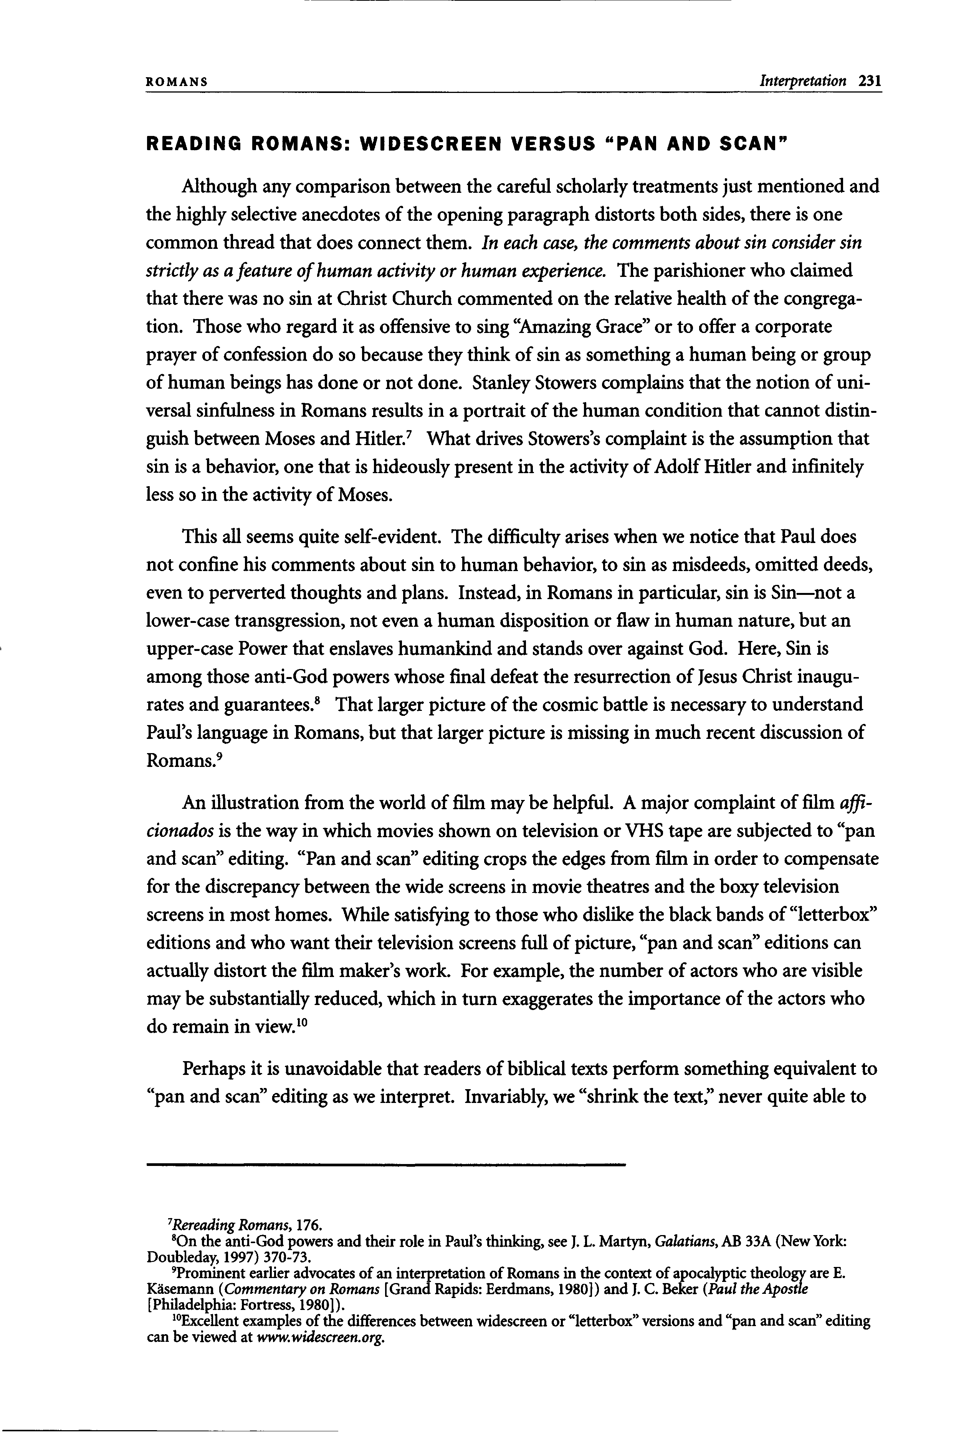
ROMANS Interpretation 231
READING ROMANS: WIDESCREEN VERSUS "PAN AND SCAN"
Although any comparison between the careful scholarly treatments just mentioned and the highly selective anecdotes of the opening paragraph distorts both sides, there is one common thread that does connect them. In each case, the comments about sin consider sin strictly as a feature of human activity or human experience. The parishioner who claimed that there was no sin at Christ Church commented on the relative health of the congrega- tion. Those who regard it as offensive to sing "Amazing Grace" or to offer a corporate prayer of confession do so because they think of sin as something a human being or group of human beings has done or not done. Stanley Stowers complains that the notion of uni- versal sinfulness in Romans results in a portrait of the human condition that cannot distin-
7
guish between Moses and Hitler.
sin is a behavior, one that is hideously present in the activity of Adolf Hitler and infinitely less so in the activity of Moses.
This all seems quite self-evident. The difficulty arises when we notice that Paul does
not confine his comments about sin to human behavior, to sin as misdeeds, omitted deeds,
even to perverted thoughts and plans. Instead, in Romans in particular, sin is Sin—not a
lower-case transgression, not even a human disposition or flaw in human nature, but an
upper-case Power that enslaves humankind and stands over against God. Here, Sin is
among those anti-God powers whose final defeat the resurrection of Jesus Christ inaugu-
8
rates and guarantees.
Paul's language in Romans, but that larger picture is missing in much recent discussion of
9
Romans.
An illustration from the world of film may be helpful. A major complaint of film affi-
cionados is the way in which movies shown on television or VHS tape are subjected to "pan
and scan" editing. "Pan and scan" editing crops the edges from film in order to compensate
for the discrepancy between the wide screens in movie theatres and the boxy television
screens in most homes. While satisfying to those who dislike the black bands of "letterbox"
editions and who want their television screens full of picture, "pan and scan" editions can
actually distort the film maker's work. For example, the number of actors who are visible
may be substantially reduced, which in turn exaggerates the importance of the actors who
10 do remain in view.
Perhaps it is unavoidable that readers of biblical texts perform something equivalent to "pan and scan" editing as we interpret. Invariably, we "shrink the text," never quite able to
7
Rereading Romans, 176. 8
What drives Stowers's complaint is the assumption that
That larger picture of the cosmic battle is necessary to understand
On the anti-God powers and their role in Paul's thinking, see J. L. Martyn, Galatians, AB 33A (New York:
Doubleday, 1997) 370-73. 9
Prominent earlier advocates of an interpretation of Romans in the context of apocalyptic theology are E.
Käsemann (Commentary on Romans [Grand Rapids: Eerdmans, 1980]) and J. C. Beker (Paul the Apostle
Excellent examples of the differences between widescreen or "letterbox" versions and "pan and scan" editing can be viewed at www.widescreen.org.
[Philadelphia: Fortress, 1980]). 10
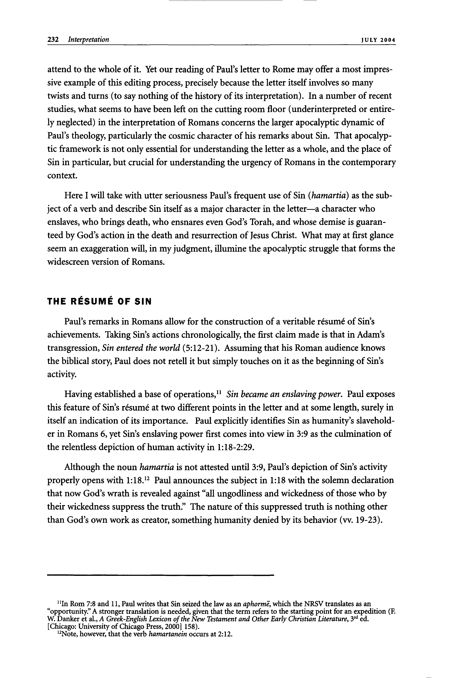
232 Interpretation JUL Y 2 0 0 4
attend to the whole of it. Yet our reading of Paul's letter to Rome may offer a most impres- sive example of this editing process, precisely because the letter itself involves so many twists and turns (to say nothing of the history of its interpretation). In a number of recent studies, what seems to have been left on the cutting room floor (underinterpreted or entire- ly neglected) in the interpretation of Romans concerns the larger apocalyptic dynamic of Paul's theology, particularly the cosmic character of his remarks about Sin. That apocalyp- tic framework is not only essential for understanding the letter as a whole, and the place of Sin in particular, but crucial for understanding the urgency of Romans in the contemporary context.
Here I will take with utter seriousness Paul's frequent use of Sin (hamartia) as the sub- ject of a verb and describe Sin itself as a major character in the letter—a character who enslaves, who brings death, who ensnares even God's Torah, and whose demise is guaran- teed by God's action in the death and resurrection of Jesus Christ. What may at first glance seem an exaggeration will, in my judgment, illumine the apocalyptic struggle that forms the widescreen version of Romans.
THE RESUME OF SIN
Paul's remarks in Romans allow for the construction of a veritable résumé of Sin's achievements. Taking Sin's actions chronologically, the first claim made is that in Adam's transgression, Sin entered the world (5:12-21). Assuming that his Roman audience knows the biblical story, Paul does not retell it but simply touches on it as the beginning of Sin's activity.
11
Having established a base of operations, Sin became an enslaving power. Paul exposes
this feature of Sin's résumé at two different points in the letter and at some length, surely in itself an indication of its importance. Paul explicitly identifies Sin as humanity's slavehold- er in Romans 6, yet Sin's enslaving power first comes into view in 3:9 as the culmination of the relentless depiction of human activity in 1:18-2:29.
Although the noun hamartia is not attested until 3:9, Paul's depiction of Sin's activity 12
properly opens with 1:18. Paul announces the subject in 1:18 with the solemn declaration that now God's wrath is revealed against "all ungodliness and wickedness of those who by their wickedness suppress the truth." The nature of this suppressed truth is nothing other than God's own work as creator, something humanity denied by its behavior (w. 19-23).
"In Rom 7:8 and 11, Paul writes that Sin seized the law as an aphormê, which the NRSV translates as an
"opportunity." A stronger translation is needed, given that the term refers to the starting point for an expedition (E
rd
W. Danker et al., A Greek-English Lexicon of the New Testament and Other Early Christian Literature, 3 ed.
[Chicago: University of Chicago Press, 2000] 158).
12
Note, however, that the verb hamartanein occurs at 2:12.
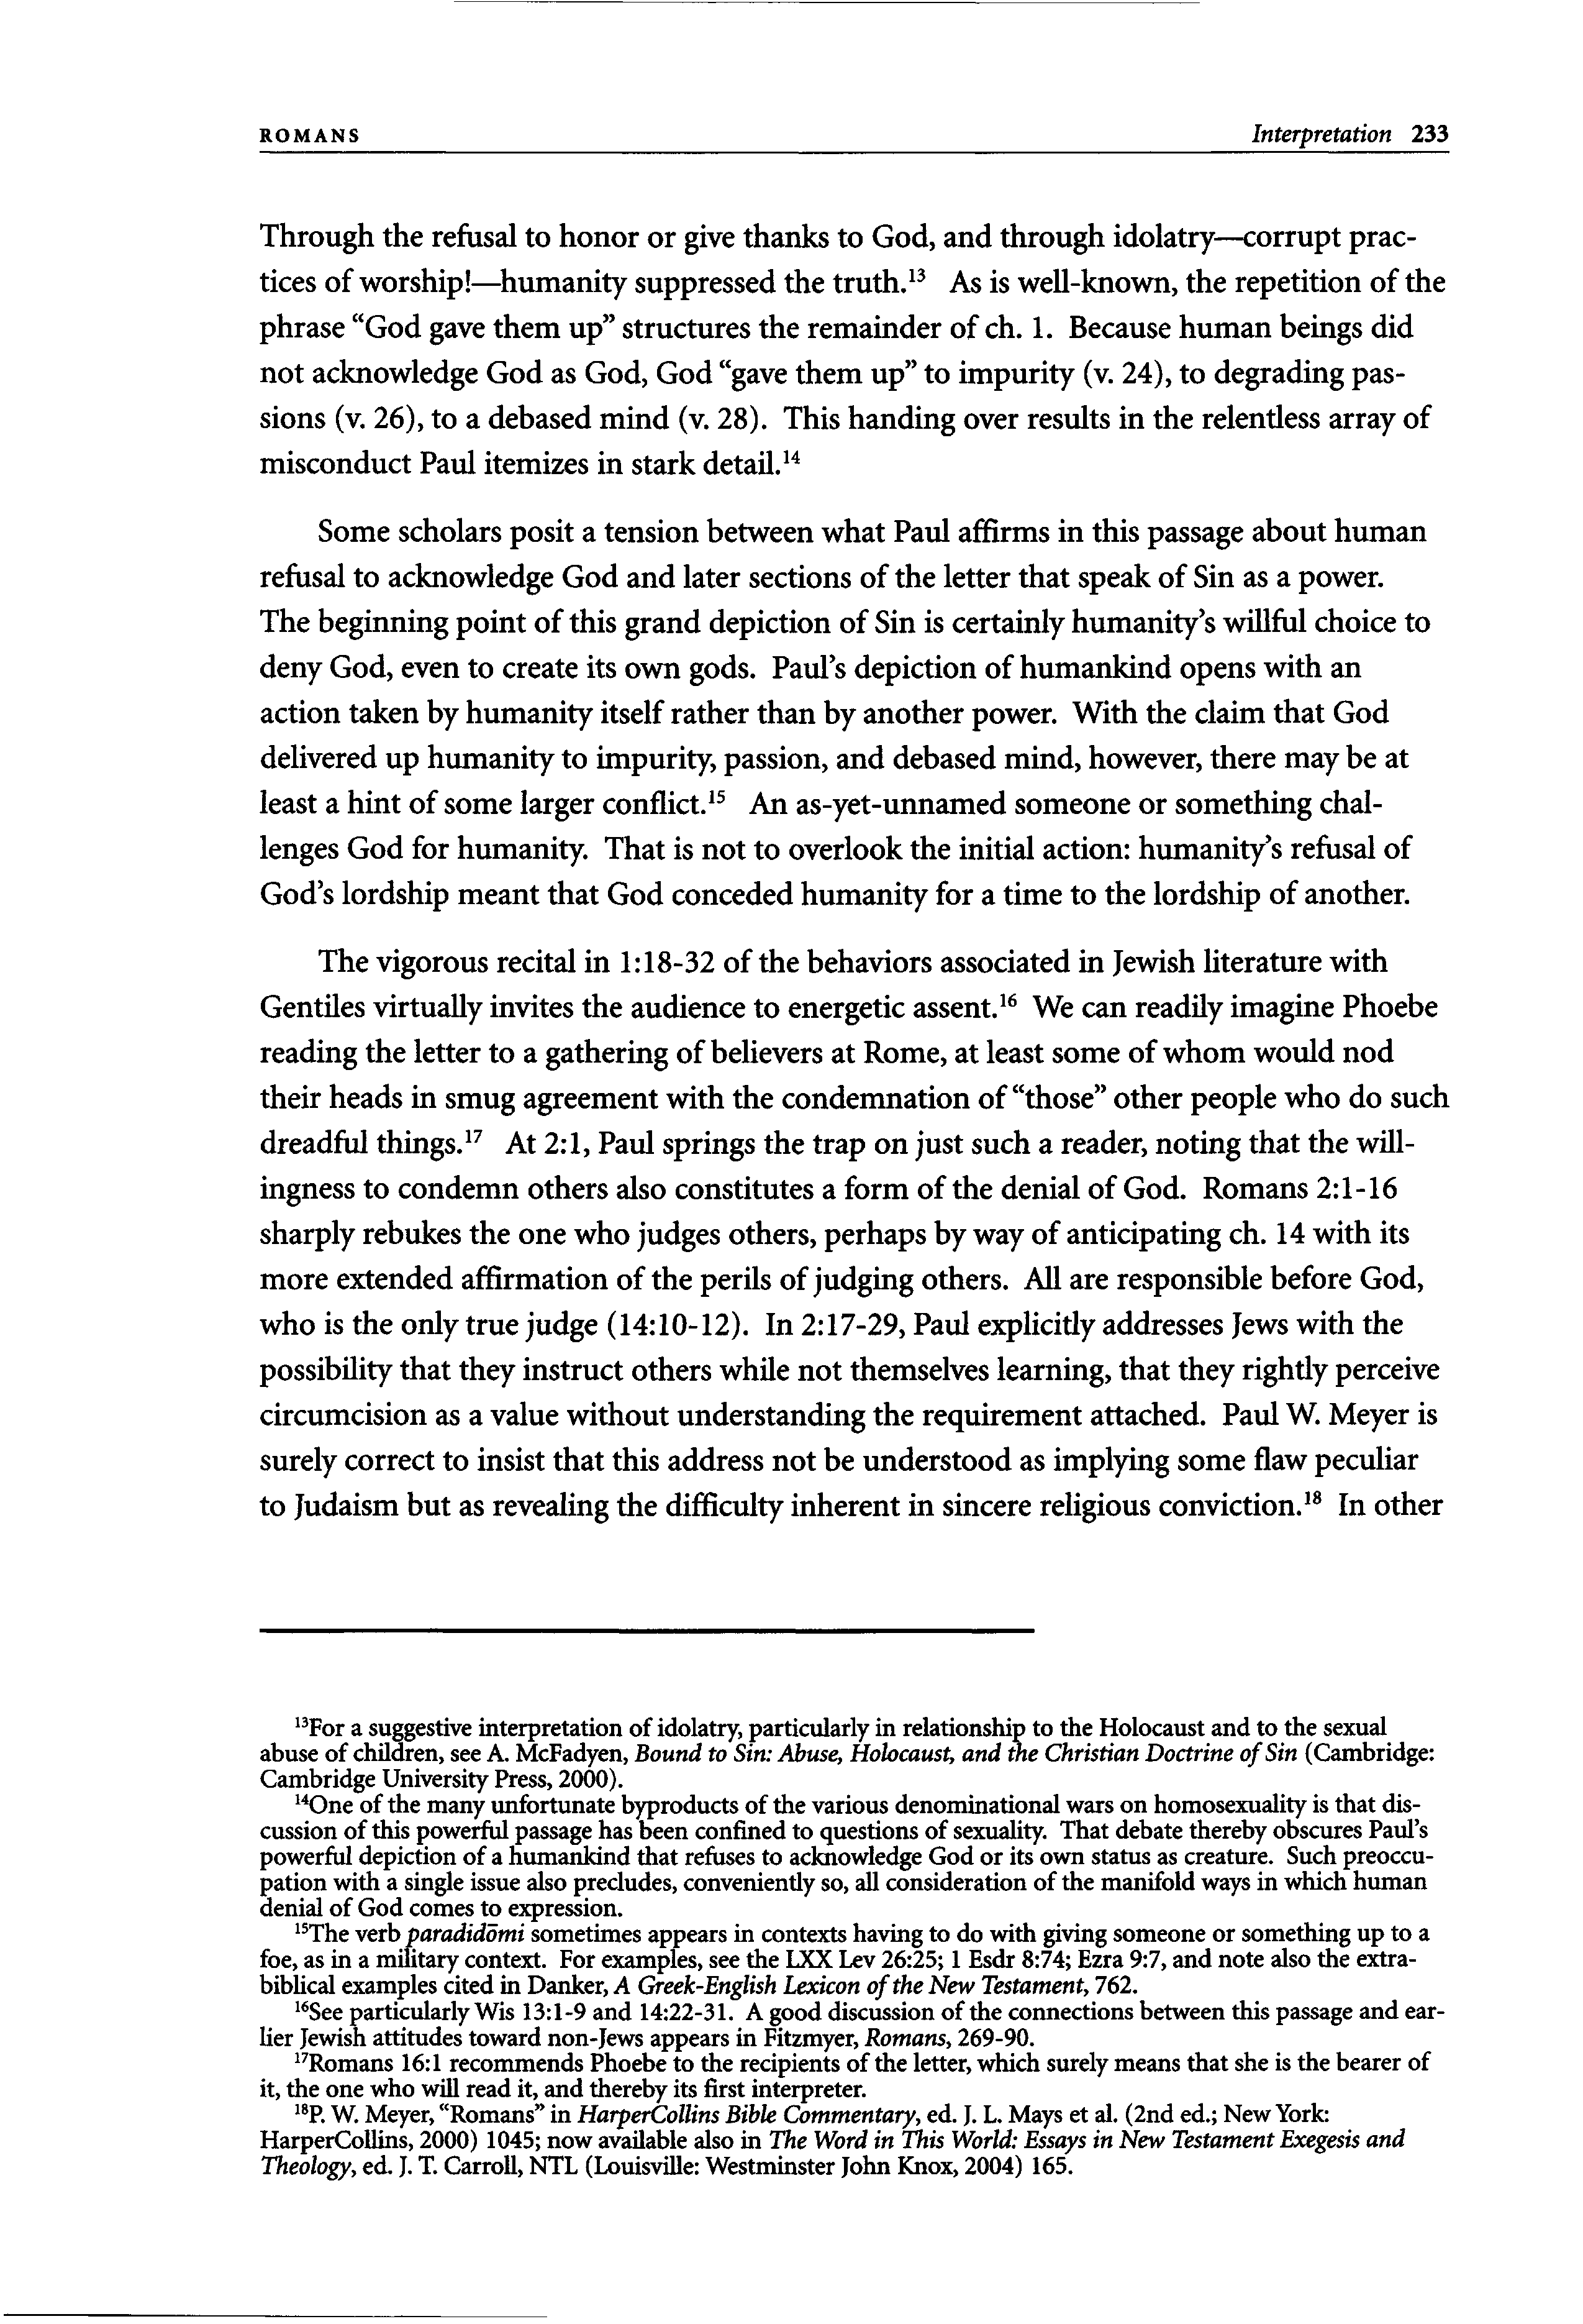
ROMANS Interpretation 233
Through the refusal to honor or give thanks to God, and through idolatry—corrupt prac-
13
tices of worship!—humanity suppressed the truth.
phrase "God gave them up" structures the remainder of ch. 1. Because human beings did not acknowledge God as God, God "gave them up" to impurity (v. 24), to degrading pas- sions (v. 26), to a debased mind (v. 28). This handing over results in the relentless array of
14
Some scholars posit a tension between what Paul affirms in this passage about human refusal to acknowledge God and later sections of the letter that speak of Sin as a power. The beginning point of this grand depiction of Sin is certainly humanity's willful choice to deny God, even to create its own gods. Paul's depiction of humankind opens with an action taken by humanity itself rather than by another power. With the claim that God delivered up humanity to impurity, passion, and debased mind, however, there may be at
15
least a hint of some larger conflict.
lenges God for humanity. That is not to overlook the initial action: humanity's refusal of God's lordship meant that God conceded humanity for a time to the lordship of another.
The vigorous recital in 1:18-32 of the behaviors associated in Jewish literature with
16
misconduct Paul itemizes in stark detail.
Gentiles virtually invites the audience to energetic assent.
We can readily imagine Phoebe
As is well-known, the repetition of the
An as-yet-unnamed someone or something chal-
reading the letter to a gathering of believers at Rome, at least some of whom would nod
their heads in smug agreement with the condemnation of "those" other people who do such
17
dreadful things.
ingness to condemn others also constitutes a form of the denial of God. Romans 2:1-16 sharply rebukes the one who judges others, perhaps by way of anticipating ch. 14 with its more extended affirmation of the perils of judging others. All are responsible before God, who is the only true judge (14:10-12). In 2:17-29, Paul explicitly addresses Jews with the possibility that they instruct others while not themselves learning, that they rightly perceive circumcision as a value without understanding the requirement attached. Paul W. Meyer is surely correct to insist that this address not be understood as implying some flaw peculiar
18
At 2:1, Paul springs the trap on just such a reader, noting that the will-
to Judaism but as revealing the difficulty inherent in sincere religious conviction.
In other
13
For a suggestive interpretation of idolatry, particularly in relationship to the Holocaust and to the sexual
abuse of children, see A. McFadyen, Bound to Sin: Abuse, Holocaust, and the Christian Doctrine of Sin (Cambridge:
Cambridge University Press, 2000). 14
One of the many unfortunate byproducts of the various denominational wars on homosexuality is that dis- cussion of this powerful passage has been confined to questions of sexuality. That debate thereby obscures Paul's powerful depiction of a humankind that refuses to acknowledge God or its own status as creature. Such preoccu- pation with a single issue also precludes, conveniently so, all consideration of the manifold ways in which human
denial of God comes to expression. 15
The verb paradiddmi sometimes appears in contexts having to do with giving someone or something up to a
foe, as in a military context. For examples, see the LXX Lev 26:25; 1 Esdr 8:74; Ezra 9:7, and note also the extra-
biblical examples cited in Danker, A Greek-English Lexicon of the New Testament, 762. 16
See particularly Wis 13:1-9 and 14:22-31. A good discussion of the connections between this passage and ear-
lier Jewish attitudes toward non-Jews appears in Fitzmyer, Romans, 269-90. 17
Romans 16:1 recommends Phoebe to the recipients of the letter, which surely means that she is the bearer of
it, the one who will read it, and thereby its first interpreter. 18
P. W. Meyer, "Romans" in HarperCollins Bible Commentary, ed. J. L. Mays et al. (2nd ed.; New York: HarperCollins, 2000) 1045; now available also in The Word in This World: Essays in New Testament Exegesis and Theology, ed. J. T. Carroll, NTL (Louisville: Westminster John Knox, 2004) 165.
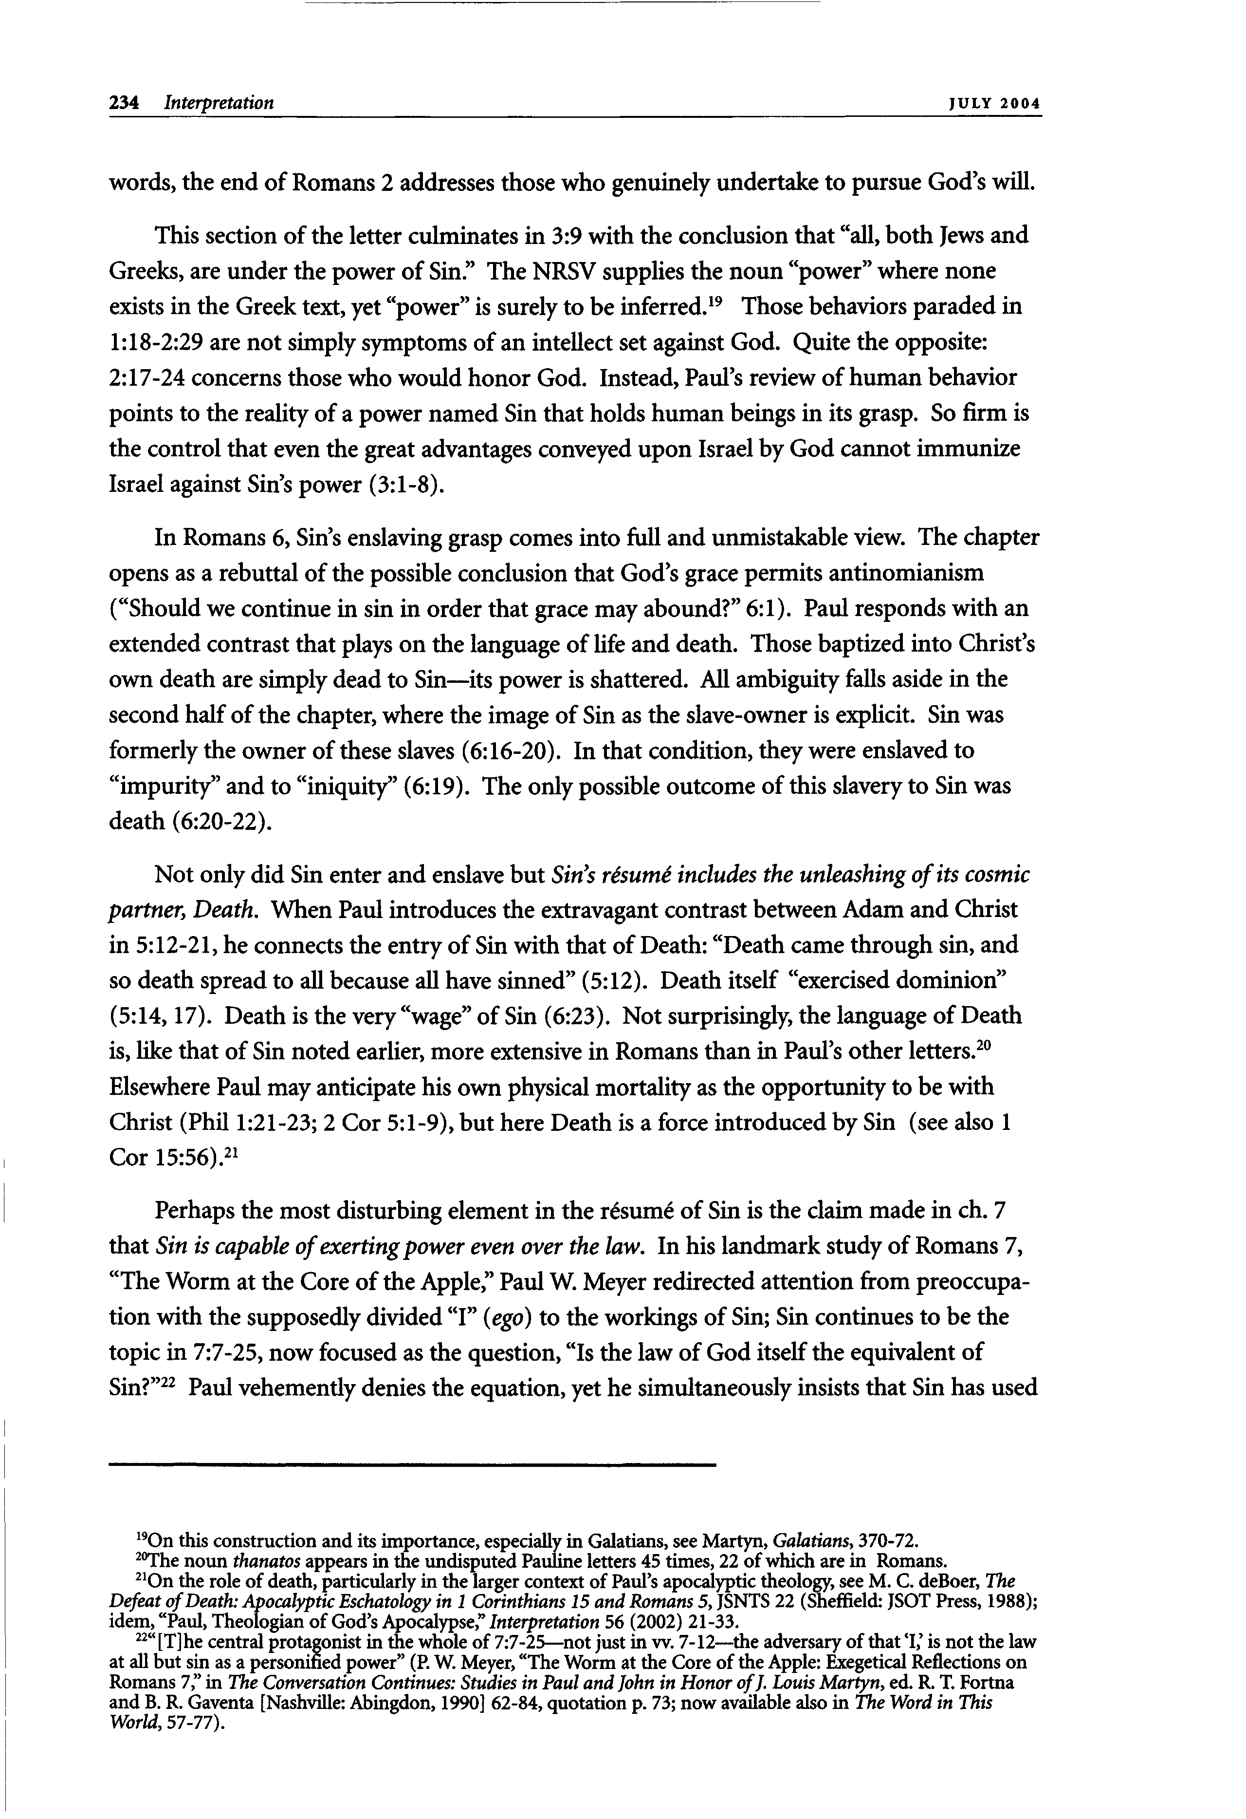
234 Interpretation JUL Y 2 0 0 4
words, the end of Romans 2 addresses those who genuinely undertake to pursue God's will.
This section of the letter culminates in 3:9 with the conclusion that "all, both Jews and Greeks, are under the power of Sin." The NRSV supplies the noun "power" where none
19
exists in the Greek text, yet "power" is surely to be inferred.
1:18-2:29 are not simply symptoms of an intellect set against God. Quite the opposite: 2:17-24 concerns those who would honor God. Instead, Paul's review of human behavior points to the reality of a power named Sin that holds human beings in its grasp. So firm is the control that even the great advantages conveyed upon Israel by God cannot immunize Israel against Sin's power (3:1-8).
In Romans 6, Sin's enslaving grasp comes into full and unmistakable view. The chapter opens as a rebuttal of the possible conclusion that God's grace permits antinomianism ("Should we continue in sin in order that grace may abound?" 6:1). Paul responds with an extended contrast that plays on the language of life and death. Those baptized into Christ's own death are simply dead to Sin—its power is shattered. All ambiguity falls aside in the second half of the chapter, where the image of Sin as the slave-owner is explicit. Sin was formerly the owner of these slaves (6:16-20). In that condition, they were enslaved to "impurity" and to "iniquity" (6:19). The only possible outcome of this slavery to Sin was death (6:20-22).
Not only did Sin enter and enslave but Sin's résumé includes the unleashing of its cosmic partner, Death. When Paul introduces the extravagant contrast between Adam and Christ
in 5:12-21, he connects the entry of Sin with that of Death: "Death came through sin, and
so death spread to all because all have sinned" (5:12). Death itself "exercised dominion"
(5:14,17). Death is the very "wage" of Sin (6:23). Not surprisingly, the language of Death
20
Elsewhere Paul may anticipate his own physical mortality as the opportunity to be with
Christ (Phil 1:21-23; 2 Cor 5:1-9), but here Death is a force introduced by Sin (see also 1
21
Perhaps the most disturbing element in the résumé of Sin is the claim made in ch. 7
that Sin is capable of exerting power even over the law. In his landmark study of Romans 7,
"The Worm at the Core of the Apple," Paul W. Meyer redirected attention from preoccupa-
tion with the supposedly divided "I" {ego) to the workings of Sin; Sin continues to be the
topic in 7:7-25, now focused as the question, "Is the law of God itself the equivalent of
22
Sin?" Paul vehemently denies the equation, yet he simultaneously insists that Sin has used
19
On this construction and its importance, especially in Galatians, see Martyn, Gahtians, 370-72.
20
The noun thanatos appears in the undisputed Pauline letters 45 times, 22 of which are in Romans.
21
On the role of death, particularly in the larger context of Paul's apocalyptic theology, see M. C. deBoer, The
Defeat ofDeath: Apocalyptic Eschatology in 1 Corinthians 15 and Romans 5, JSNTS 22 (Sheffield: JSOT Press, 1988); idem, "Paul, Theologian of God's Apocalypse," Interpretation 56 (2002) 21-33.
22
"[T]he central protagonist in the whole of 7:7-25—not just in w . 7-12—the adversary ofthat %' is not the law
at all but sin as a personified power" (P. W. Meyer, "The Worm at the Core of the Apple: Exegetical Reflections on Romans 7," in The Conversation Continues: Studies in Paul and John in Honor ofJ. Louis Martyn, ed. R. T. Fortna and B. R. Gaventa [Nashville: Abingdon, 1990] 62-84, quotation p. 73; now available also in The Word in This
World, 57-77).
is, like that of Sin noted earlier, more extensive in Romans than in Paul's other letters.
Cor 15:56).
Those behaviors paraded in
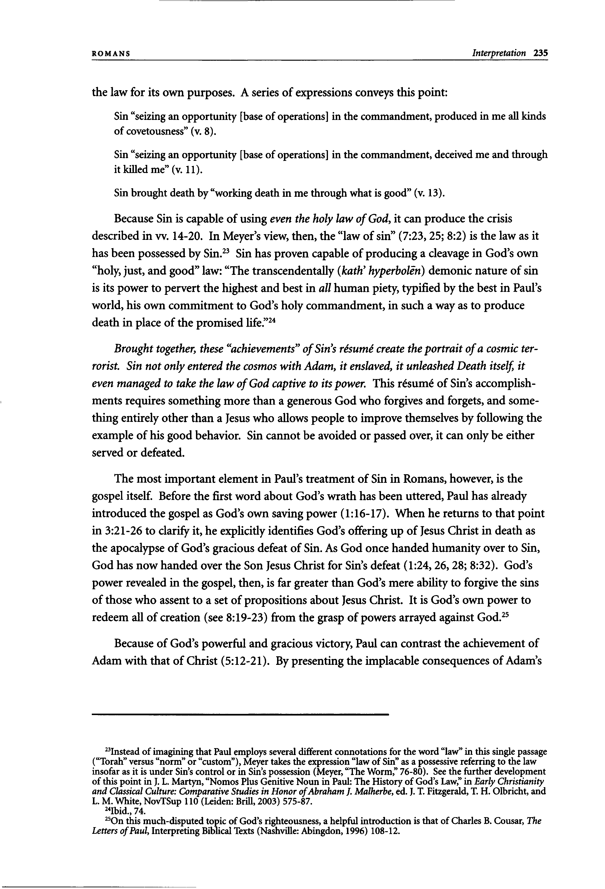
ROMANS Interpretation 235
the law for its own purposes. A series of expressions conveys this point:
Sin "seizing an opportunity [base of operations] in the commandment, produced in me all kinds
>>
of covetousness (v. 8).
Sin "seizing an opportunity [base of operations] in the commandment, deceived me and through it killed me" (v. 11).
Sin brought death by "working death in me through what is good" (v. 13).
Because Sin is capable of using even the holy law of God, it can produce the crisis described in w . 14-20. In Meyer's view, then, the "law of sin" (7:23,25; 8:2) is the law as it
23
has been possessed by Sin.
"holy, just, and good" law: "The transcendentally (kath' hyperbolên) demonic nature of sin is its power to pervert the highest and best in all human piety, typified by the best in Paul's world, his own commitment to God's holy commandment, in such a way as to produce
24 death in place of the promised life."
Brought together, these "achievements" of Sin's résumé create the portrait of a cosmic ter- rorist. Sin not only entered the cosmos with Adam, it enslaved, it unleashed Death itself, it even managed to take the law of God captive to its power. This résumé of Sin's accomplish- ments requires something more than a generous God who forgives and forgets, and some- thing entirely other than a Jesus who allows people to improve themselves by following the example of his good behavior. Sin cannot be avoided or passed over, it can only be either served or defeated.
The most important element in Paul's treatment of Sin in Romans, however, is the gospel itself. Before the first word about God's wrath has been uttered, Paul has already introduced the gospel as God's own saving power (1:16-17). When he returns to that point in 3:21-26 to clarify it, he explicitly identifies God's offering up of Jesus Christ in death as the apocalypse of God's gracious defeat of Sin. As God once handed humanity over to Sin, God has now handed over the Son Jesus Christ for Sin's defeat (1:24,26,28; 8:32). God's power revealed in the gospel, then, is far greater than God's mere ability to forgive the sins of those who assent to a set of propositions about Jesus Christ. It is God's own power to
25
Because of God's powerful and gracious victory, Paul can contrast the achievement of Adam with that of Christ (5:12-21). By presenting the implacable consequences of Adam's
23
Instead of imagining that Paul employs several different connotations for the word "law" in this single passage
("Torah" versus "norm" or "custom"), Meyer takes the expression "law of Sin" as a possessive referring to the law
insofar as it is under Sin's control or in Sin's possession (Meyer, "The Worm," 76-80). See the further development
of this point in J. L. Martyn, "Nomos Plus Genitive Noun in Paul: The History of God's Law," in Early Christianity and Classical Culture: Comparative Studies in Honor ofAbraham J. Malherbe, ed. J. T. Fitzgerald, T. H. Olbricht, and
L. M. White, NovTSup 110 (Leiden: Brill, 2003) 575-87. 24
On this much-disputed topic of God's righteousness, a helpful introduction is that of Charles B. Cousar, The Letters ofPaul, Interpreting Biblical Texts (Nashville: Abingdon, 1996) 108-12.
Sin has proven capable of producing a cleavage in God's own
redeem all of creation (see 8:19-23) from the grasp of powers arrayed against God.
Ibid., 74. 25
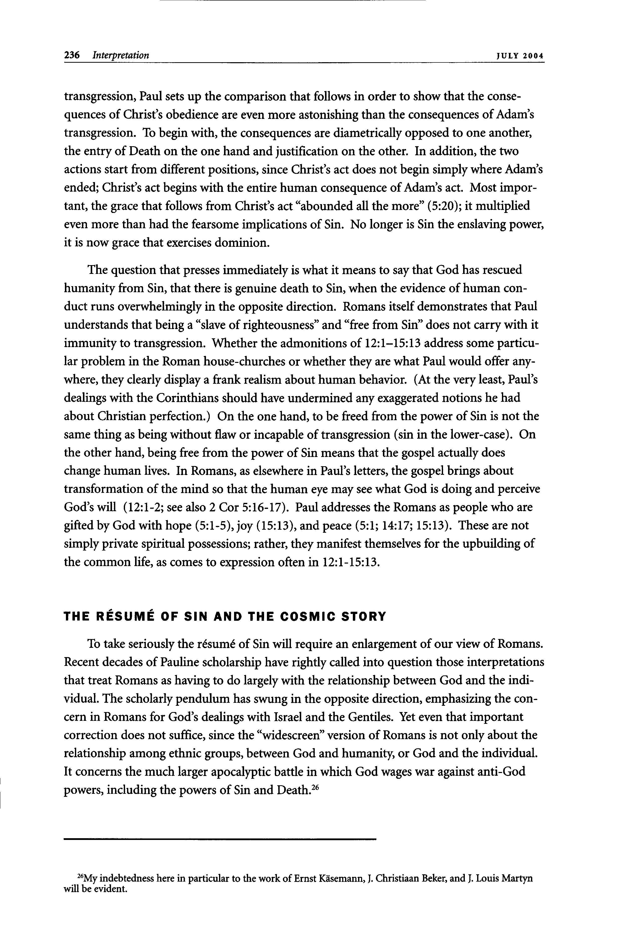
236 Interpretation JUL Y 2 0 0 4
transgression, Paul sets up the comparison that follows in order to show that the conse- quences of Christ's obedience are even more astonishing than the consequences of Adam's transgression. To begin with, the consequences are diametrically opposed to one another, the entry of Death on the one hand and justification on the other. In addition, the two actions start from different positions, since Christ's act does not begin simply where Adam's ended; Christ's act begins with the entire human consequence of Adam's act. Most impor- tant, the grace that follows from Christ's act "abounded all the more" (5:20); it multiplied even more than had the fearsome implications of Sin. No longer is Sin the enslaving power, it is now grace that exercises dominion.
The question that presses immediately is what it means to say that God has rescued humanity from Sin, that there is genuine death to Sin, when the evidence of human con- duct runs overwhelmingly in the opposite direction. Romans itself demonstrates that Paul understands that being a "slave of righteousness" and "free from Sin" does not carry with it immunity to transgression. Whether the admonitions of 12:1-15:13 address some particu- lar problem in the Roman house-churches or whether they are what Paul would offer any- where, they clearly display a frank realism about human behavior. (At the very least, Paul's dealings with the Corinthians should have undermined any exaggerated notions he had about Christian perfection.) On the one hand, to be freed from the power of Sin is not the same thing as being without flaw or incapable of transgression (sin in the lower-case). On the other hand, being free from the power of Sin means that the gospel actually does change human lives. In Romans, as elsewhere in Paul's letters, the gospel brings about transformation of the mind so that the human eye may see what God is doing and perceive God's will (12:1-2; see also 2 Cor 5:16-17). Paul addresses the Romans as people who are gifted by God with hope (5:1-5), joy (15:13), and peace (5:1; 14:17; 15:13). These are not simply private spiritual possessions; rather, they manifest themselves for the upbuilding of the common life, as comes to expression often in 12:1-15:13.
THE RESUME OF SIN AND THE COSMIC STORY
To take seriously the résumé of Sin will require an enlargement of our view of Romans. Recent decades of Pauline scholarship have rightly called into question those interpretations that treat Romans as having to do largely with the relationship between God and the indi- vidual. The scholarly pendulum has swung in the opposite direction, emphasizing the con- cern in Romans for God's dealings with Israel and the Gentiles. Yet even that important correction does not suffice, since the "widescreen" version of Romans is not only about the relationship among ethnic groups, between God and humanity, or God and the individual. It concerns the much larger apocalyptic battle in which God wages war against anti-God
26
26
My indebtedness here in particular to the work of Ernst Käsemann, J. Christiaan Beker, and J. Louis Martyn
powers, including the powers of Sin and Death.
will be evident.
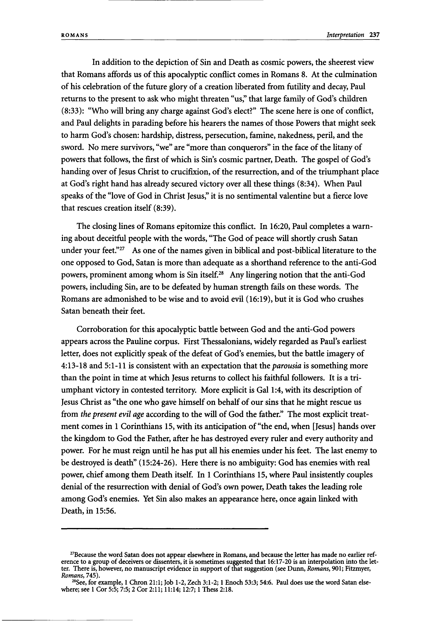
ROMANS Interpretation 237
In addition to the depiction of Sin and Death as cosmic powers, the sheerest view that Romans affords us of this apocalyptic conflict comes in Romans 8. At the culmination of his celebration of the future glory of a creation liberated from futility and decay, Paul returns to the present to ask who might threaten "us," that large family of God's children (8:33): "Who will bring any charge against God's elect?" The scene here is one of conflict, and Paul delights in parading before his hearers the names of those Powers that might seek to harm God's chosen: hardship, distress, persecution, famine, nakedness, peril, and the sword. No mere survivors, "we" are "more than conquerors" in the face of the litany of powers that follows, the first of which is Sin's cosmic partner, Death. The gospel of God's handing over of Jesus Christ to crucifixion, of the resurrection, and of the triumphant place at God's right hand has already secured victory over all these things (8:34). When Paul speaks of the "love of God in Christ Jesus," it is no sentimental valentine but a fierce love that rescues creation itself (8:39).
The closing lines of Romans epitomize this conflict. In 16:20, Paul completes a warn-
ing about deceitful people with the words, "The God of peace will shortly crush Satan
27
under your feet." As one of the names given in biblical and post-biblical literature to the
one opposed to God, Satan is more than adequate as a shorthand reference to the anti-God
28
powers, prominent among whom is Sin itself. Any lingering notion that the anti-God
powers, including Sin, are to be defeated by human strength fails on these words. The Romans are admonished to be wise and to avoid evil (16:19), but it is God who crushes Satan beneath their feet.
Corroboration for this apocalyptic battle between God and the anti-God powers appears across the Pauline corpus. First Thessalonians, widely regarded as Paul's earliest letter, does not explicitly speak of the defeat of God's enemies, but the battle imagery of 4:13-18 and 5:1-11 is consistent with an expectation that the parousia is something more than the point in time at which Jesus returns to collect his faithful followers. It is a tri- umphant victory in contested territory. More explicit is Gal 1:4, with its description of Jesus Christ as "the one who gave himself on behalf of our sins that he might rescue us from the present evil age according to the will of God the father." The most explicit treat- ment comes in 1 Corinthians 15, with its anticipation of "the end, when [Jesus] hands over the kingdom to God the Father, after he has destroyed every ruler and every authority and power. For he must reign until he has put all his enemies under his feet. The last enemy to be destroyed is death" (15:24-26). Here there is no ambiguity: God has enemies with real power, chief among them Death itself. In 1 Corinthians 15, where Paul insistently couples denial of the resurrection with denial of God's own power, Death takes the leading role among God's enemies. Yet Sin also makes an appearance here, once again linked with Death, in 15:56.
27
Because the word Satan does not appear elsewhere in Romans, and because the letter has made no earlier ref-
erence to a group of deceivers or dissenters, it is sometimes suggested that 16:17-20 is an interpolation into the let-
ter. There is, however, no manuscript evidence in support ofthat suggestion (see Dunn, Romans, 901; Fitzmyer,
Romans, 745). 28
See, for example, 1 Chron 21:1; Job 1-2, Zech 3:1-2; 1 Enoch 53:3; 54:6. Paul does use the word Satan else- where; see 1 Cor 5:5; 7:5; 2 Cor 2:11; 11:14; 12:7; 1 Thess 2:18.
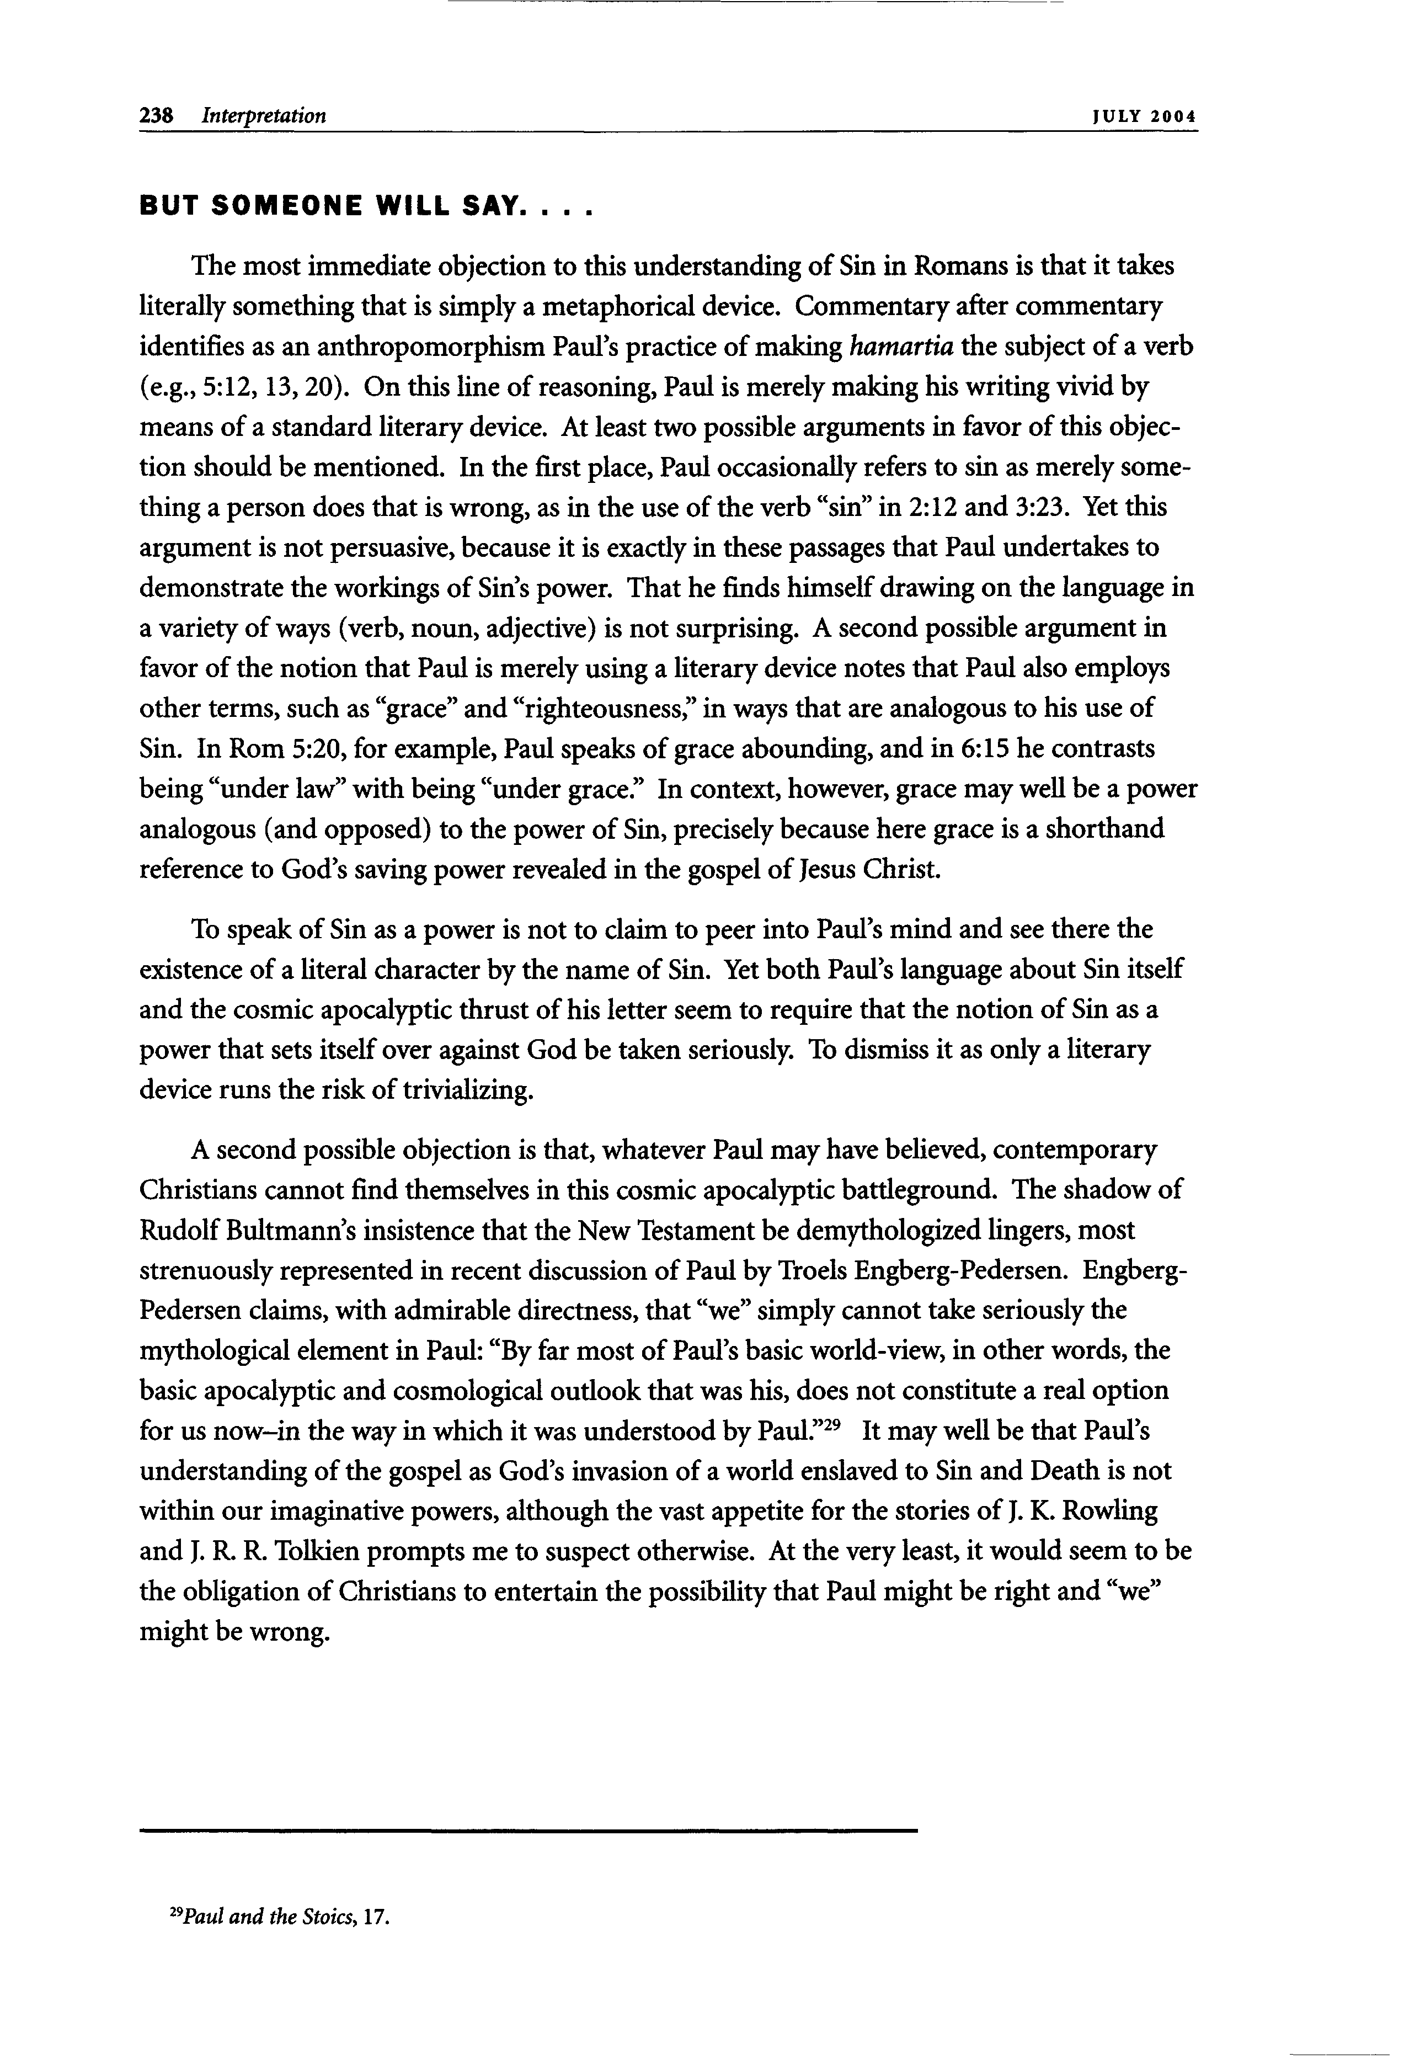
238 Interpretation JUL Y 2 0 0 4
BUT SOMEONE WILL SAY. . . .
The most immediate objection to this understanding of Sin in Romans is that it takes literally something that is simply a metaphorical device. Commentary after commentary identifies as an anthropomorphism Paul's practice of making hamartia the subject of a verb (e.g., 5:12,13,20). On this line of reasoning, Paul is merely making his writing vivid by means of a standard literary device. At least two possible arguments in favor of this objec- tion should be mentioned. In the first place, Paul occasionally refers to sin as merely some- thing a person does that is wrong, as in the use of the verb "sin" in 2:12 and 3:23. Yet this argument is not persuasive, because it is exactly in these passages that Paul undertakes to demonstrate the workings of Sin's power. That he finds himself drawing on the language in a variety of ways (verb, noun, adjective) is not surprising. A second possible argument in favor of the notion that Paul is merely using a literary device notes that Paul also employs other terms, such as "grace" and "righteousness," in ways that are analogous to his use of Sin. In Rom 5:20, for example, Paul speaks of grace abounding, and in 6:15 he contrasts being "under law" with being "under grace." In context, however, grace may well be a power analogous (and opposed) to the power of Sin, precisely because here grace is a shorthand reference to God's saving power revealed in the gospel of Jesus Christ.
To speak of Sin as a power is not to claim to peer into Paul's mind and see there the existence of a literal character by the name of Sin. Yet both Paul's language about Sin itself and the cosmic apocalyptic thrust of his letter seem to require that the notion of Sin as a power that sets itself over against God be taken seriously. To dismiss it as only a literary device runs the risk of trivializing.
A second possible objection is that, whatever Paul may have believed, contemporary Christians cannot find themselves in this cosmic apocalyptic battleground. The shadow of Rudolf Bultmann's insistence that the New Testament be demythologized lingers, most strenuously represented in recent discussion of Paul by Troels Engberg-Pedersen. Engberg- Pedersen claims, with admirable directness, that "we" simply cannot take seriously the mythological element in Paul: "By far most of Paul's basic world-view, in other words, the basic apocalyptic and cosmological outlook that was his, does not constitute a real option
29
for us now-in the way in which it was understood by Paul." It may well be that Paul's
understanding of the gospel as God's invasion of a world enslaved to Sin and Death is not within our imaginative powers, although the vast appetite for the stories of J. K. Rowling and J. R. R. Tolkien prompts me to suspect otherwise. At the very least, it would seem to be the obligation of Christians to entertain the possibility that Paul might be right and "we" might be wrong.
29
Paul and the Stoics, 17.
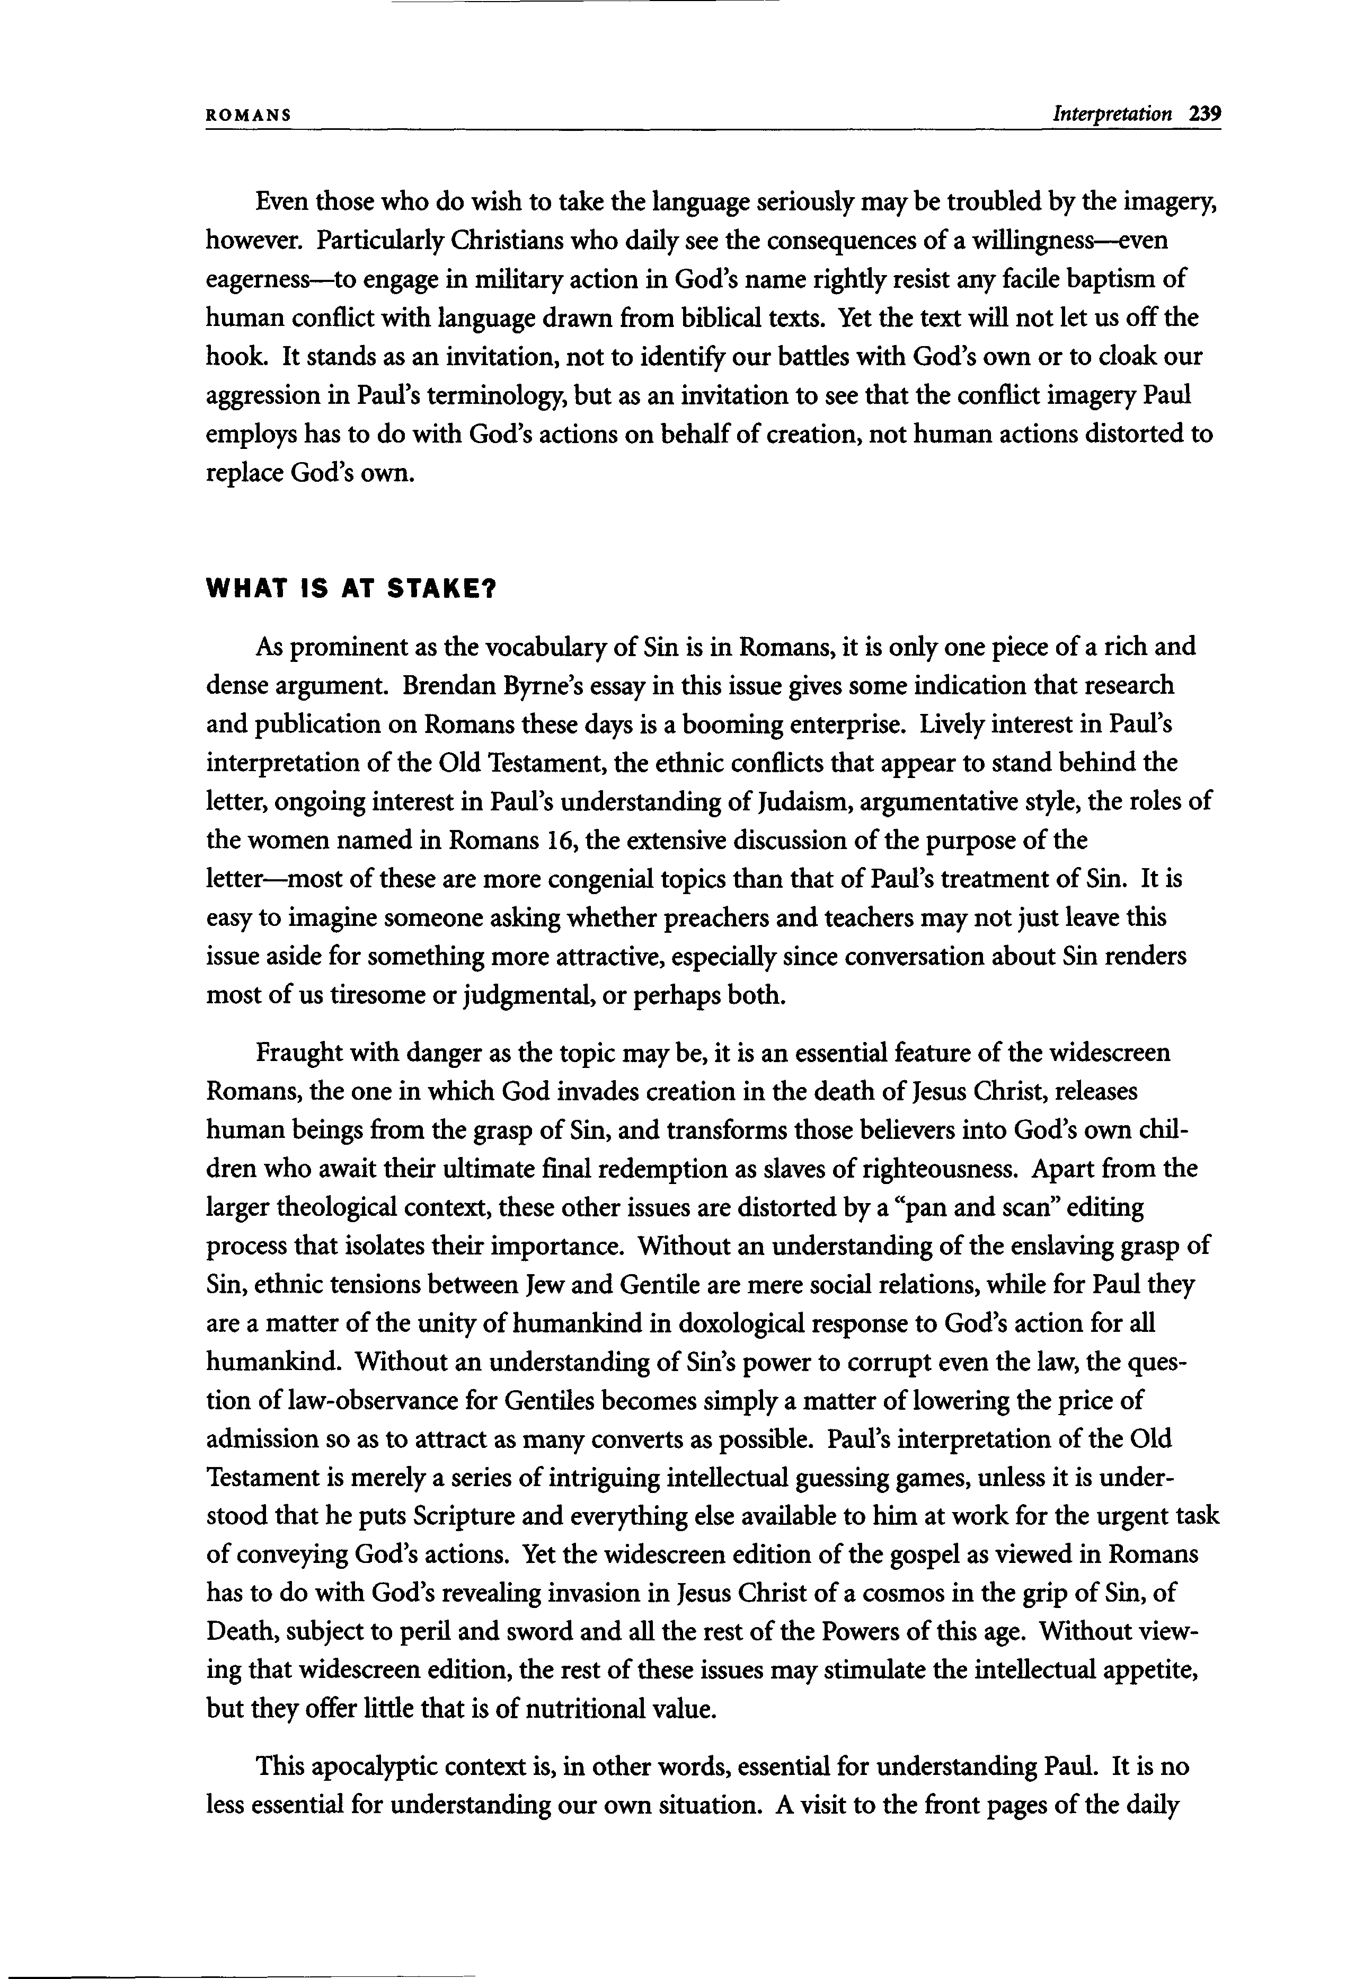
ROMANS Interpretation 239
Even those who do wish to take the language seriously may be troubled by the imagery, however. Particularly Christians who daily see the consequences of a willingness—even eagerness—to engage in military action in God's name rightly resist any facile baptism of human conflict with language drawn from biblical texts. Yet the text will not let us off the hook. It stands as an invitation, not to identify our battles with God's own or to cloak our aggression in Paul's terminology, but as an invitation to see that the conflict imagery Paul employs has to do with God's actions on behalf of creation, not human actions distorted to replace God's own.
WHAT IS AT STAKE?
As prominent as the vocabulary of Sin is in Romans, it is only one piece of a rich and dense argument. Brendan Byrne's essay in this issue gives some indication that research and publication on Romans these days is a booming enterprise. Lively interest in Paul's interpretation of the Old Testament, the ethnic conflicts that appear to stand behind the letter, ongoing interest in Paul's understanding of Judaism, argumentative style, the roles of the women named in Romans 16, the extensive discussion of the purpose of the letter—most of these are more congenial topics than that of Paul's treatment of Sin. It is easy to imagine someone asking whether preachers and teachers may not just leave this issue aside for something more attractive, especially since conversation about Sin renders most of us tiresome or judgmental, or perhaps both.
Fraught with danger as the topic may be, it is an essential feature of the widescreen Romans, the one in which God invades creation in the death of Jesus Christ, releases human beings from the grasp of Sin, and transforms those believers into God's own chil- dren who await their ultimate final redemption as slaves of righteousness. Apart from the larger theological context, these other issues are distorted by a "pan and scan" editing process that isolates their importance. Without an understanding of the enslaving grasp of Sin, ethnic tensions between Jew and Gentile are mere social relations, while for Paul they are a matter of the unity of humankind in doxological response to God's action for all humankind. Without an understanding of Sin's power to corrupt even the law, the ques- tion of law-observance for Gentiles becomes simply a matter of lowering the price of admission so as to attract as many converts as possible. Paul's interpretation of the Old Testament is merely a series of intriguing intellectual guessing games, unless it is under- stood that he puts Scripture and everything else available to him at work for the urgent task of conveying God's actions. Yet the widescreen edition of the gospel as viewed in Romans has to do with God's revealing invasion in Jesus Christ of a cosmos in the grip of Sin, of Death, subject to peril and sword and all the rest of the Powers of this age. Without view- ing that widescreen edition, the rest of these issues may stimulate the intellectual appetite, but they offer little that is of nutritional value.
This apocalyptic context is, in other words, essential for understanding Paul. It is no less essential for understanding our own situation. A visit to the front pages of the daily
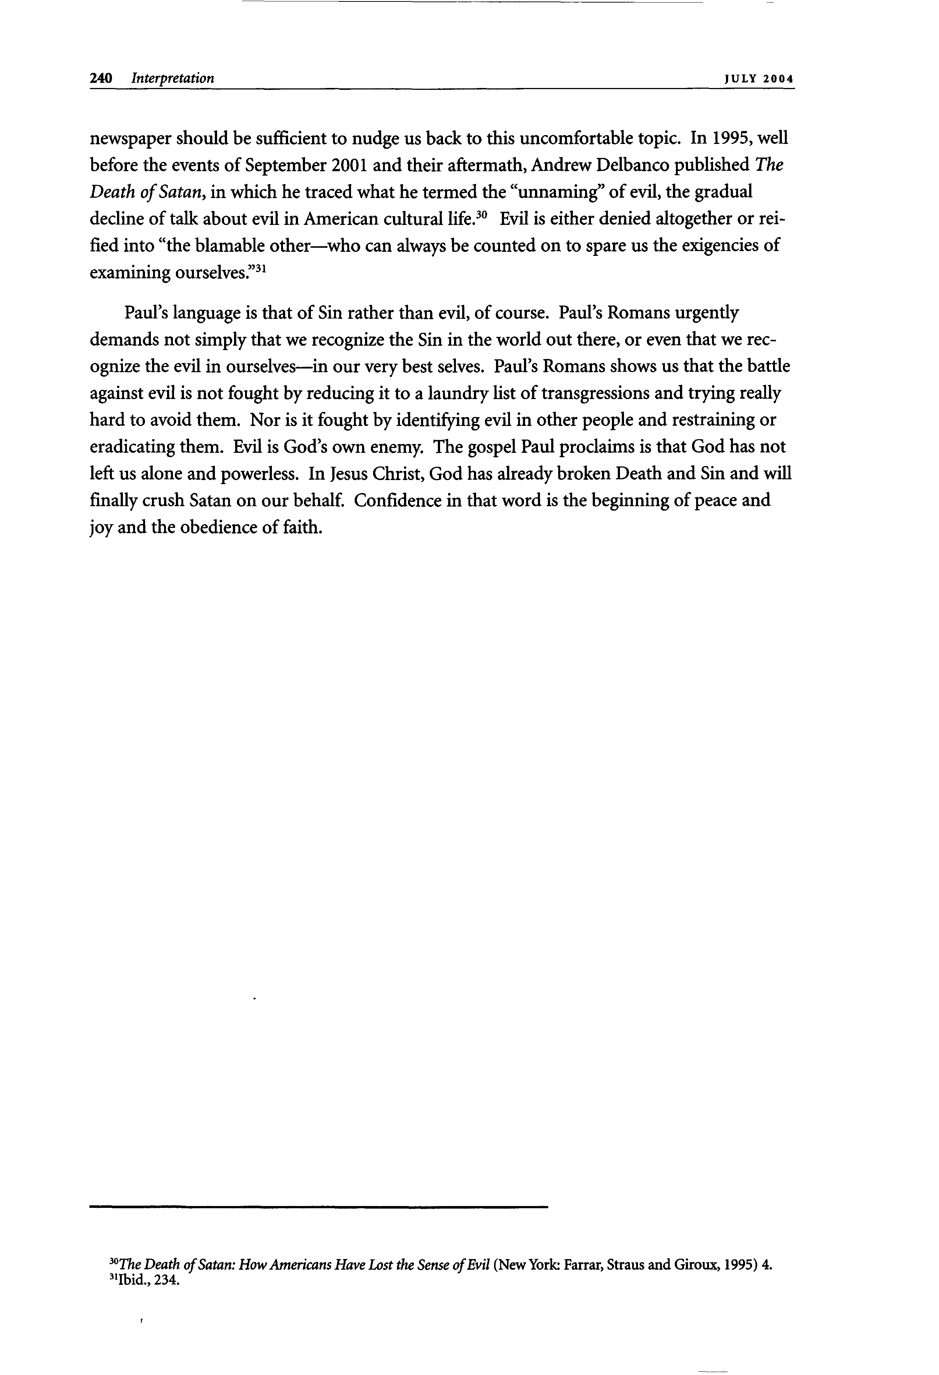
240 Interpretation JUL Y 2 0 0 4
newspaper should be sufficient to nudge us back to this uncomfortable topic. In 1995, well
before the events of September 2001 and their aftermath, Andrew Delbanco published The
Death of Satan, in which he traced what he termed the "unnaming" of evil, the gradual
30
decline of talk about evil in American cultural life.
Evil is either denied altogether or rei-
fied into "the blamable other—who can always be counted on to spare us the exigencies of
31 examining ourselves."
Paul's language is that of Sin rather than evil, of course. Paul's Romans urgently demands not simply that we recognize the Sin in the world out there, or even that we rec- ognize the evil in ourselves—in our very best selves. Paul's Romans shows us that the battle against evil is not fought by reducing it to a laundry list of transgressions and trying really hard to avoid them. Nor is it fought by identifying evil in other people and restraining or eradicating them. Evil is God's own enemy. The gospel Paul proclaims is that God has not left us alone and powerless. In Jesus Christ, God has already broken Death and Sin and will finally crush Satan on our behalf. Confidence in that word is the beginning of peace and joy and the obedience of faith.

